Spark Assignment [23-12-2023]

By Karthikeyan K R

Basic Functions of PySpark

**Read:**

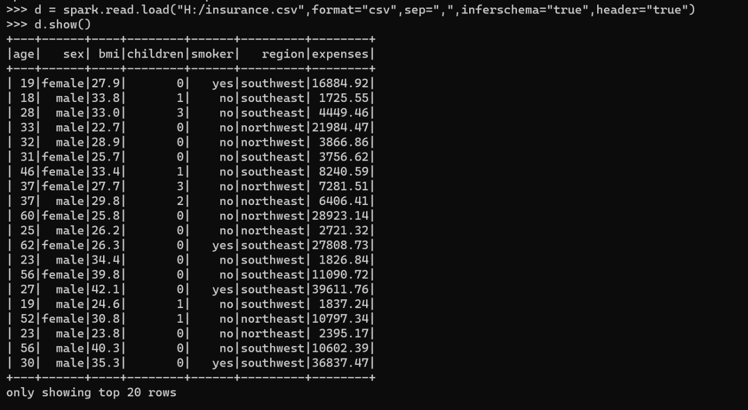

**Reading the data using pandas**

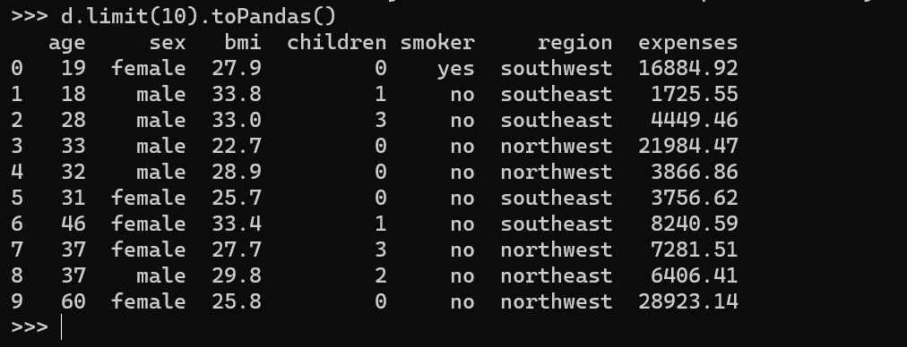

**Select Command**

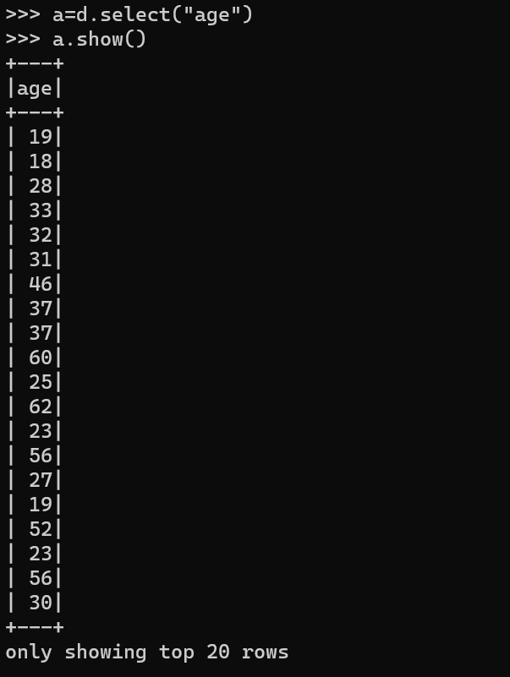

**Sort Command**

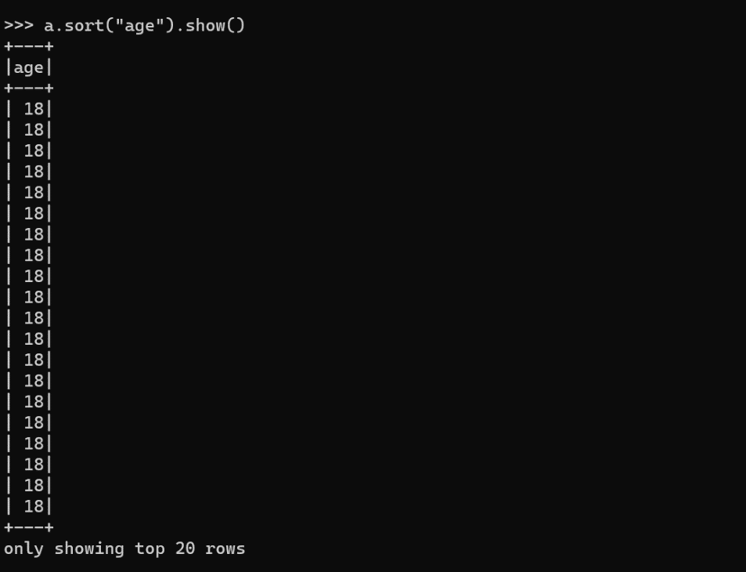

**Filter Command**

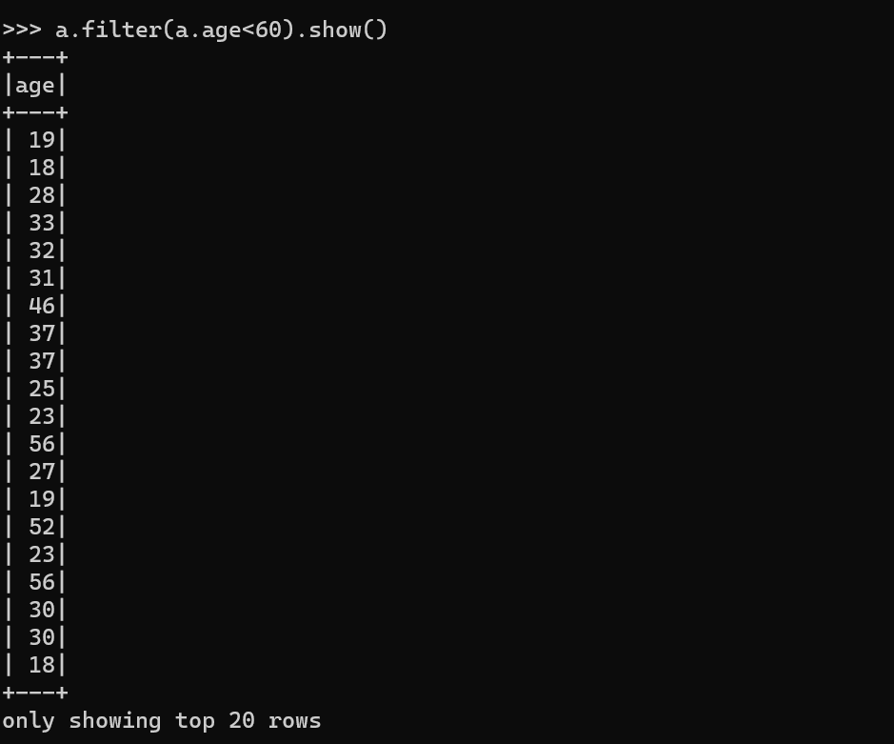

Basic of Commands of Spark

**Starting the Spark-Shell**

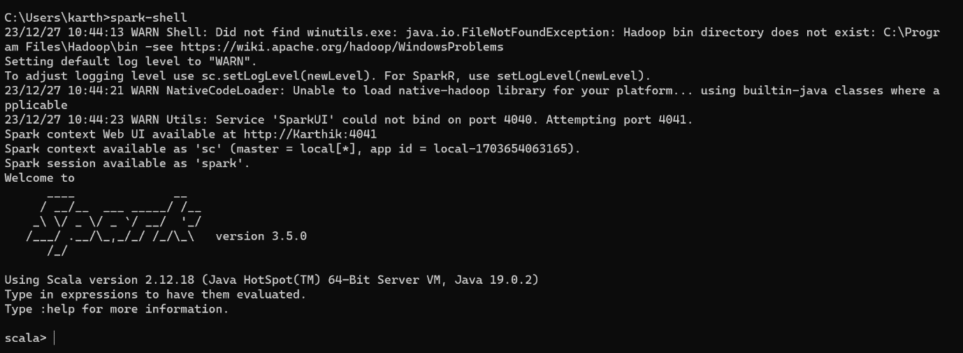

**Read the data from file**

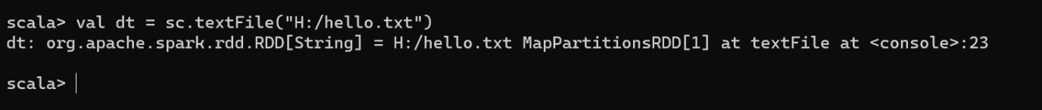

**Create RDD through Parallelizing**

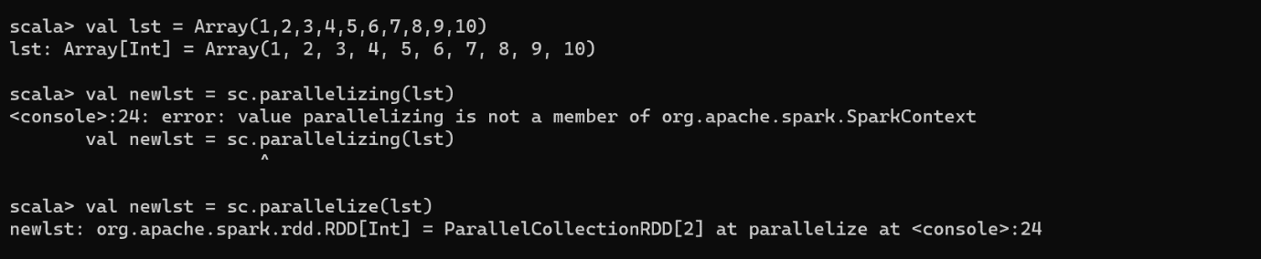

**Count items in RDD**

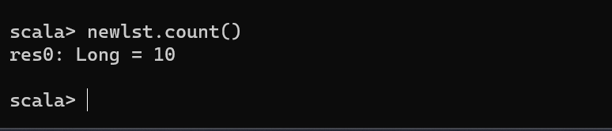

**Reading the data from RDD**

